W4D1 Homework

1. Design the tables in database, attention their relationship and the constraint (primary key, foreign key)

**User**   
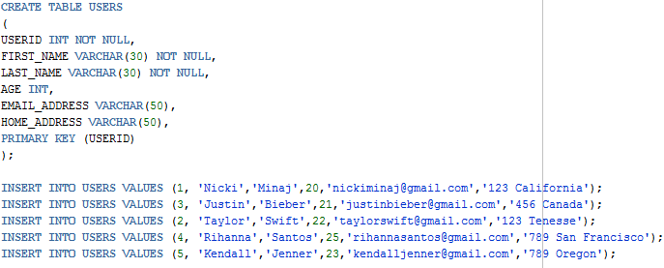

**Order**

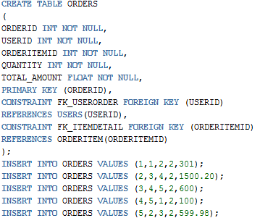

**OrderItem**

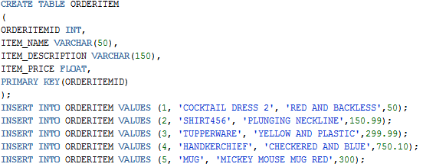

1. What are DQL, DML, DDL and DCL for Database? And what their commands? And give examples for each one based the above tables “User”, “Order” and “OrderItem”.   
     
   **Data Query Language**  
   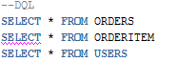

**Data Manipulation Language**  
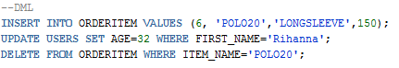

**Data Definition Language**  
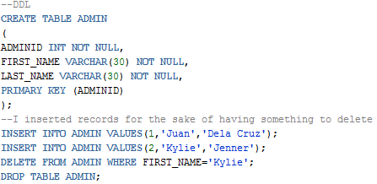

**Data Control Language**

